(Approx. 1045 words)

Talk, Texts, Data – How much, and for how much?
By Phil Sorrentino, By Phil Sorrentino, Newsletter Contributor, Sarasota Technology Users Group
www.thestug.org
philsorr (at) yahoo.com
As you probably know by now, along with a smartphone comes a phone plan. This plan defines how you will be charged, by your Wireless provider, for using your phone. Some of the more popular Wireless providers are AT&T, Verizon, & T-Mobile, because those three companies own the three major wireless networks in this country. In addition to those three, there are resellers like Consumer Cellular, Mint Mobile, Ting, and Boost Mobile. (A reseller is an organization that sells wireless services under its own name but uses the networks of other service providers, for example, Ting uses T-Mobile.) If you have a “completely unlimited” plan, that is, no limits on the number of talk minutes, texts, and especially data, the rest of this article is just academic because you pay one price no matter how or how much you use your phone, but if you don’t have a completely unlimited plan, this may be interesting. Many plans that sound like (completely) unlimited plans are unlimited talk and text with typically a very large Data allotment, but not complete data. (A completely unlimited plan for a single phone may be around $70/month, but less if you have multiple lines. For example, I have seen an unlimited plan advertised as $37.50/month each for two lines; that’s $75/month for two unlimited lines.)
“Talk” time is the number of minutes you can use your phone for voice cellular phone calls. This would be the time you spend on your phone talking to people who are using smartphones, flip phones, or even home phones. Phone calls are from phone to phone, so you need a phone number for the phone call recipient. Phone calls typically go via the cellular phone network (cell phone towers), though you may be able to use wi-fi calling under certain conditions. Talk minutes are relatively inexpensive; they are almost free with most plans. If you want a plan with only talk minutes, they can currently be had for around $20/month with unlimited minutes or about $15/month with around 250 minutes. Talk used to be the whole reason for having and using a phone, but now there are many more uses for the smartphone.
“Texts” is the number of typically short typed-in messages that are sent immediately to the phone number you have chosen from your contact list. Texts (text messages) can only be sent from one phone to another, so you need a phone number to be the recipient of the text message. (Smartphone, Flip phone, probably not a home phone.) Texts typically go via the cellular phone network (cell phone towers) but can go via wi-fi if you are in the vicinity of a wi-fi router. (Note: Data is used for attachments to texts.) Texts have become a fairly common way to keep in touch with people because of their instant messaging nature. A text is immediately sent to the recipient, giving him the message and the ability to answer immediately or at a future time.
“Data” is the amount of “data” that is transmitted over the cellular phone network (cell phone towers). Data allotments typically come in GigaByte or half GigaByte increments (some may even be in hundreds of MegaBytes). Data allotments may be on a per-line basis, or with some plans, the data can be shared among a group of phones in a so-called family plan. When you are out and about, even traveling in your car, all the data transmitted to and from your phone is charged against your monthly data allotment. Fortunately, when you are not out and about and you are in the vicinity of a wi-fi router, the data that gets transmitted is not charged against your monthly data allotment. (You have already paid the Internet Service Provider for the use of the wi-fi as part of your monthly Internet bill.)
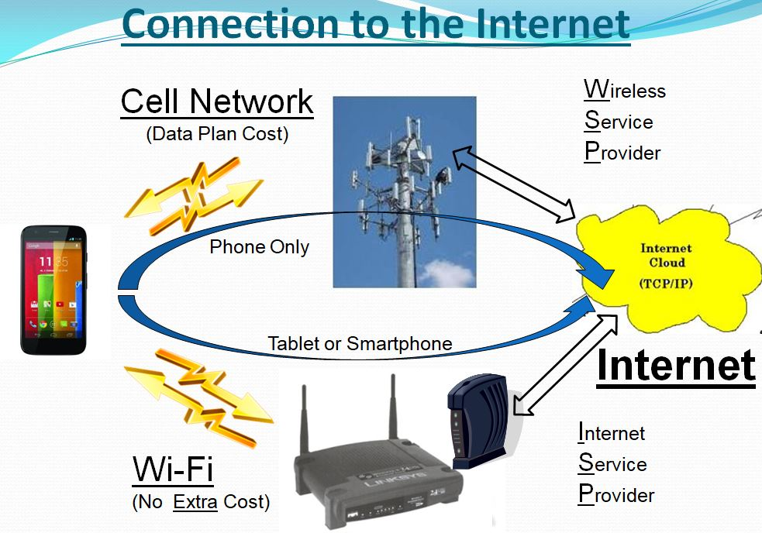
Data may be transmitted from your phone by any widget or open App. (Keep in mind that widgets are open as long as your phone is not powered off. Fortunately, most widgets use very little data.) Many Apps need a constant flow of data to keep their information current; Maps and Waze are two apps that come to mind. All of the Apps on your phone are designed to be the Client in the Client-Server computing model. These Apps can only do their job when connected to their server. (The internet provides the connection via cell phone towers or wi-fi.)

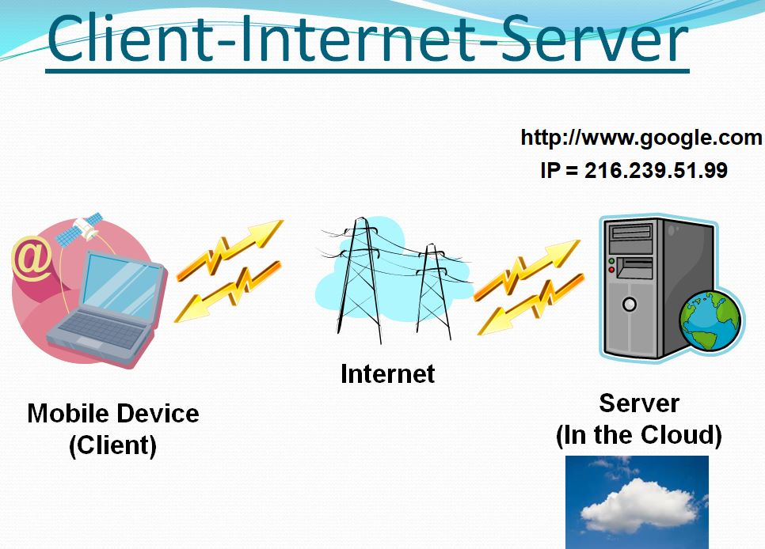
If an App is not closed after it is used, it may still be transmitting data to, and receiving data from its server, even if you are not looking at one of its screens. So, if you don’t have an unlimited plan, make sure you close any app you will not use. If you don’t want to use any data at a given time, most phones can turn off the Data, typically in “Settings.” Make sure you leave yourself a reminder to turn Data back on afterward. (With the Data turned off, you will still be able to make and receive voice calls and probably texts, though you will probably not be able to receive attachments, like pictures, to texts.) Data is really what makes the smartphone so useful and versatile. Data makes the smartphone a personal digital assistant with endless uses, gives you access to enormous databases, and provides answers almost instantaneously.
As you can see from the amount of information describing talk, texts, and data, the emphasis is on data. The cost of most plans is directly correlated to the amount of data; it almost seems that talk and texts are just about thrown in at no extra charge. It is the fact that your smartphone can interact with a much more capable server at the other end of the internet that gives your smartphone all of its various amazing capabilities. It is data that lets us check our email, consult our calendar, find the nearest Japanese restaurant, keep in touch with people, and research and purchase items on Amazon or many other retailers on the internet, all without us moving from the comfort of our homes, offices, or automobiles.

